Virtual and In-Person at Blue Lake Rancheria

July 29 - August 21, 2025

**Purpose:** to build technical & soft skills and with hands-on training preparing individuals to enter and succeed in a registered apprenticeship or other careers in the electric field; Program is co-designed by Blue Lake Rancheria, Hoopa Valley, Karuk, and Yurok Tribes.

**Contact:** Ysabelle Yrad, Sustainability Specialist at Blue Lake Rancheria | yyrad@bluelakerancheria-nsn.gov | (707) 668-5101

**Requirements:** No prior experience is required. It is required that pre-apprentices

* Attend all virtual and in-person sessions (please be on time),
* Must be interested in a career as an electrician,
* Must complete a screening questionnaire and end of program survey,
* Must complete OSHA 10 training module and provide program administrators a copy of the certificate, and
* Must be prepared for each session, including having the ability to access program materials and virtual zoom sessions. No laptops or computers are provided.

**Required Homework, Due August 21:** Pre-apprentices must complete an OSHA 10-Hour Construction Course online and provide program administrators a copy of the certificate. Only those who submit a copy of an existing OSHA 10 or 30 certification can opt-out of this requirement. A link to register for the course will be sent via email to participants on the first day of class, July 29, 2025.

Do not wait to start this homework until the last minute. Expect to spend a MINIMUM of 10 hours to complete this homework on your own.

**How to Access Program Resources & Zoom:** Participants can access all program materials on the Blue Lake Rancheria website <https://www.bluelakerancheria-nsn.gov/electricians-program/> under the ‘Student Resources’ button. Password: blrtribe. Do not share password outside of program participants.

All virtual sessions use the SAME zoom link: <https://bluelakerancheria.zoom.us/j/97885118783?pwd=o035mqS3DqEuoHMz4lvSKpxF9YTCHM.1> Meeting ID: 978 8511 8783 Passcode: 624560

**In-Person Extended Weekend Participation:** Participants should be prepared to attend all in-person sessions scheduled below. Special accommodations should be requested ahead of time. Participants who are traveling from locations outside of the Blue Lake, Eureka/Arcata, and McKinleyville areas will be sent an additional travel form for program coordinators to book their hotel accommodations for them. All others will be asked to commute to Blue Lake Rancheria, as there are limited hotel rooms for the summer season. All meals and breaks are included. See last page for directions.

**Program Schedule (subject to change):**

| **Schedule** | **Date / Time (PST)** | **Learning Module(s)** | **Hours** | **In-Person / Virtual** | **Instructor(s) / Guest Speaker(s)** | **Description** |
| --- | --- | --- | --- | --- | --- | --- |
| Week 1,  Session 1 | **Tuesday July 29,**  **5-7pm** | **Introduction to Construction Math** | 2 | Virtual | Bob Jones (Meskwaki Apprenticeship Lead Electrical Instructor) | Conceptual understanding of mathematics and developing efficiency in problem solving with whole numbers and fractions, including lowest comment denominators, improper fractions, adding/subtracting fractions, and multiplying/dividing fractions. |
| Week 1,  Session 2 | **Thursday July 31,**  **5-7pm** | **Introduction to Construction Math** | 2 | Virtual | Bob Jones (Meskwaki Apprenticeship Lead Electrical Instructor) | Conceptual understanding of mathematics and developing efficiency in measuring length and metric/inch-pound measurement systems. Provides introduction to geometry, angles/shapes, calculating the area of shapes and volume of three-dimensional shapes. |
| Week 2, Session 3 | **Tuesday Aug 5,**  **5-7pm** | **Introduction to Construction Math**  **and**  **Introduction to Union Work** | 2 | Virtual | Bob Jones (Meskwaki Apprenticeship Lead Electrical Instructor)  Guest Speaker: Jared Mumm, (IBEW 551 Representative) | Review conceptual understanding of mathematics and developing efficiency in problem solving using practice study problems.  Provides overview of local union apprenticeship program and experience of being a union electrician. |
|
| Week 2, Session 4 | **Thursday Aug 7,**  **5-8pm** | **Understanding How to Work with and for Tribal Nations** | 3 | Virtual | Ian Record: Tribal Sovereignty 101  Melvin Wheeler and Laatis Lawrence (Nez Perce): What you need to know about Tribal Employment Rights Offices (TEROs)  Ray Wiseman (Yakama Power): Working as a low-voltage electrician on Tribal lands  Heidi Moore-Guynup (Blue Lake Rancheria): MMIP Awareness and Protection and Clean Energy Opportunities  Linnea Jackson (Hoopa Valley Utilities District): Clean Energy Opportunities and Tribal Utilities Work | Develop proficient understanding of Tribal Sovereignty, special considerations when working within Tribal communities, and learn local career opportunities working as a low-voltage electrician on Tribal lands. Provides overview of functions of Tribal Employment Rights Offices. |
| Week 3,  Session 5 | **Tuesday Aug 12,**  **5-7pm** | **Achieving Readiness to Thrive in the Workplace** | 2 | Virtual | Guest Speaker  *GRID Alternatives IBT 200 Program* | Equips participants with key skills, knowledge, and behaviors that are necessary to successfully transition into and thrive within the workforce. Includes identifying “soft skills” and personal obstacles to workplace readiness, accessing Tribal services to support you in removing those obstacles, finding and keeping a healthy work-life balance, and building healthy relationships with your supervisor/employer. |
| Week 3,  Session 6 | **Thursday Aug 14,**  **5-7pm** | **Achieving Readiness to Thrive in the Workplace** | 2 | Virtual | Guest Speakers  Penny Cordova (Hoopa Valley TERO)  Ysabelle Yrad (Blue Lake Rancheria)  *Citizen Potawatomi Nation, Blackfeet Community College, Tulalip Tribes Vocational Training Center* |
| **Extended Weekend Session** | **Friday Aug 15, 12:30 - 3:30pm** | **CPR Training** (Optional for those with active CPR training) | 3 | **In-Person** at Claudia Brundin Health Center, Blue Lake | Kiser CPR Instructor | Covers CPR certification and basic first aid for adults, infants, and children. This course meets all OSHA requirements.  *Includes hosted lunch on site prior to start of training.* |
| **Extended Weekend Session** | **Friday, Aug 15,**  **4-7pm** | **Introduction to Electrical & Construction Drawings** | 3 | **In-Person** at Claudia Brundin Health Center, Blue Lake | Local instructor  *Blue Lake Rancheria Facilities, College of the Redwoods Instructor* | Interpreting electrical drawings, including the use of architect’s and engineer’s scales.  *Includes hosted dinner on site.* |
| **Extended Weekend Session** | **Saturday Aug 16, 9am-5pm** | **Introduction to Hand/Power Tools** | 8 | **In-Person,** at Claudia Brundin Health Center, Blue Lake | **Frank Richards** (Building Lives By Building Structure Journeyman Carpenter and Lead Instructor)  **Derek Glavich** (College of the Redwoods Construction Tech Professor) | Usage and maintenance of a broad collection of hand tools used in the construction trades. Build wall on site.  *Includes hosted lunch & meal voucher for dinner on site.* |
| **Extended Weekend Session** | **Sunday Aug 17, 8am - 12pm** | **Introduction to Electrical Circuits** | 4 | **In-Person,** at Claudia Brundin Health Center, Blue Lake | Local instructor  *Blue Lake Rancheria Facilities, College of the Redwoods Instructor* | Basic atomic and electrical theory and electrical units of measurement. Introduction to electrical schematic diagrams. Install switches and circuits in wall on site.  *Includes hosted lunch on site.* |
| **Extended Weekend Session** | **Sunday Aug 17,**  **1-3:30pm** | **Hands-on Demonstration & Job Site Orientation - Tour of BLR Microgrid** | 2.5 | **In-Person** at Blue Lake, CA | *BLR Building, Construction, & Utilities Dept* | Observe what typical job site environment looks like and tour solar microgrid technology |
| Week 4,  Session 7 | **Tuesday Aug 19,**  **5-7pm** | **Building a Rewarding Career in the Electrician Field** | 2 | Virtual | Bob Jones (Meskwaki Apprenticeship Lead Electrical Instructor)  Local Guest Speakers  *Grid Alternatives* | Overview of paths for local/regional apprenticeships, full-time employment, or other upward training programs. Provides key essentials for growing in your job and advancing through the ranks from professional electricians and workforce representatives. |
| Week 4,  Session 8 | **Thursday Aug 21,**  **5-7pm** | **Building a Rewarding Career in the Electrician Field** | 2 | Virtual | Bob Jones (Meskwaki Apprenticeship Lead Electrical Instructor)  Guest Speakers: *Hannah Seymour (Cowichan Tribes)*, Jared Mumm (IBEW)  Heidi Moore-Guynup (Blue Lake Rancheria) |
| **DUE BY AUGUST 21: Completed OSHA 10 and copy of certification is submitted** | | | | | | |
| **Total Hours** | | | **48 Hours including OSHA 10** | | | |

**In-Person Extended Weekend at Blue Lake Rancheria Directions**

Location for all classes and hosted meals: Claudia Brundin Health Center (Red ‘Health Clinic’ marked on map) on 5 Hlow Lane Blue Lake, CA 95525. For GPS directions: At the traffic circle, take the 1st exit onto Chartin Road. Then take the 1st right onto Hlow Lane.

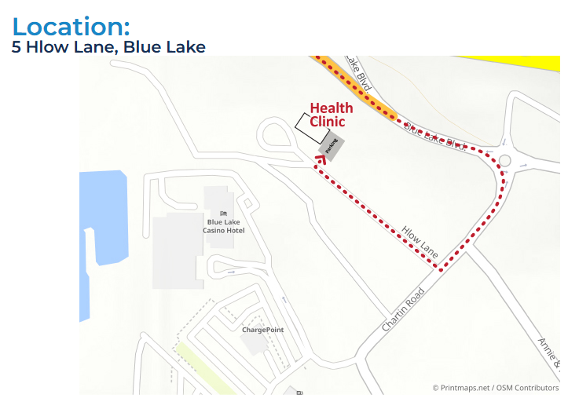

Location for overnight stay: Blue Lake Hotel on 777 Casino Way Blue Lake, CA 95525 (less than 5 minute walk to Claudia Brundin Health Center)